ARDUINO IOT DEMO

CHEAT SHEET

**Contact Information**

Max Prasad, 480-792-4020, Max.Prasad@microchip.com

**Execution Instructions**

1. Connect computer to the internet.
2. Connect Arduino Uno to the computer using a USB A/B cable.
3. Open the folder *C:\MASTERs\ArduinoEveningClass\Solutions\Lab 3*
4. Open *lab3-visuals.html* using web browser. This window displays the charts. This web page is also available at:

*http://maxmiaggi.github.io/lab3-visuals.html*

(allow to load unsafe scripts).

1. Open command prompt and execute:

*node "C:\MASTERs\ArduinoEveningClass\Solutions\Lab 3\lab3-server.js"*

This should automatically detect the serial port, open up the connection, and start executing the code.

1. Let it execute forever. To stop the execution, press Ctrl+C twice.

**Troubleshooting**

If something doesn’t work or if there are any errors, then try and see if any of the following fixes it.

1. Stop execution of node by pressing Ctrl+C twice. Then re-run it.
2. Power cycle the Arduino board.
3. Check the hardware connections.
4. Check internet connection.
5. Call Max! ☺

**Description**

The 10,000 foot view – Arduino reads data from the sensors connected to it (3 sensors – photoresistor, MCP9808 temp sensor, and potentiometer), sends it to the internet. Another remote device/computer reads that data and plots it on a chart. We connect Arduino Uno to the computer because it doesn’t has internet connection, it uses the computer’s internet connection to send data to the cloud.

**What’s happening between the computer and Arduino Uno?**

This!

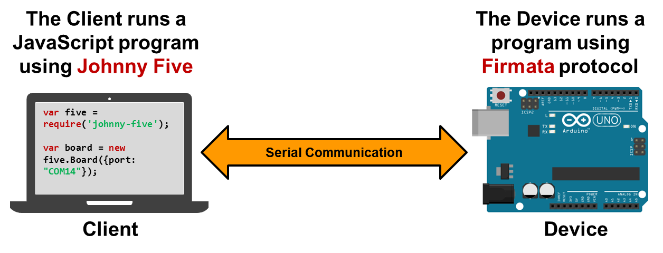

Firmata is a protocol for communication between a PC/tablet/computer and a microcontroller over UART.

Johnny Five is the JavaScript implementation of Firmata for a client computer. It is a Robotics and IoT platform.

***To learn more, attend the “Getting Started with Johnny Five” evening class on Thursday 7:30 pm at Grand Canyon 3.***

**What’s happening after that?**

This!

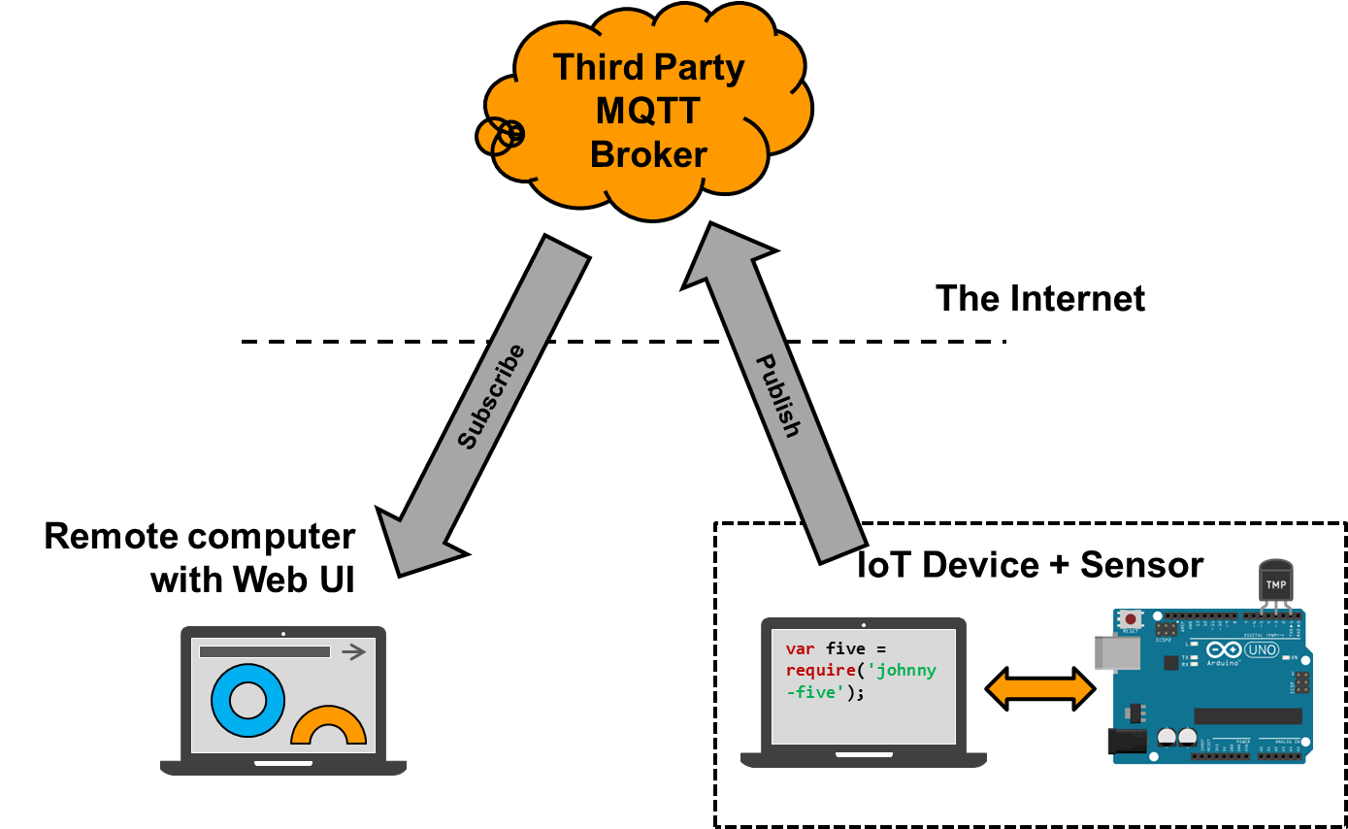

**5**

**4**

**3**

**2**

**1**

Here’s the sequence of events:

1. The Arduino Uno reads data from the sensors and sends it to the computer via Firmata protocol.
2. The computer has a JavaScript program running on it, which sends/receives data to/from Arduino using Johnny Five.
3. The computer packages and publishes sensor data to the cloud (a third party MQTT broker).
4. The MQTT broker (in this demo, we use PubNub) receives the data and sends it to all the devices that have subscribed to receive it.
5. The remove computer has a JavaScript program running that listens to the subscribed data and plots them on a chart.

***To learn more, attend the “Getting Started with Johnny Five” evening class on Thursday 7:30 pm at Grand Canyon 3.***